Week 5 Internship Documentation
Infosys Springboard Internship | Data Visualization Domain
Topic Focus: ETL Process, Detailed EDA, Missing Value Analysis, and Outlier Detection
Prepared by: Prabhakar Kumar Shahi
Project: Optimizing IT Support Team Performance Using Analytics


1. Introduction
During Week 5 of the internship, the focus moved to a more advanced and professional stage of data analysis by studying ETL (Extract, Transform, Load) and EDA (Exploratory Data Analysis) in detail. This week was highly important because it helped in understanding how raw data becomes analysis-ready and how the dataset can be explored deeply before final dashboard creation. The learning covered ETL from basic to advanced level, detailed EDA methods, missing value analysis, outlier detection, and visualization of empty versus filled values in the dataset.
For the project 'Optimizing IT Support Team Performance Using Analytics,' this week is critical because accurate insights depend on a strong ETL process and thorough exploratory analysis. EDA helps identify patterns, anomalies, trends, and hidden relationships in the support ticket data, while ETL ensures that the data is properly prepared and loaded into Power BI for reliable reporting.

2. ETL (Extract, Transform, Load) – From Basic to Pro Level
ETL is a foundational process in data analytics, business intelligence, and data engineering. It refers to the structured pipeline through which raw data is collected, cleaned, transformed, and loaded into a system where it can be analyzed. In Power BI projects, ETL is usually performed using Power Query.
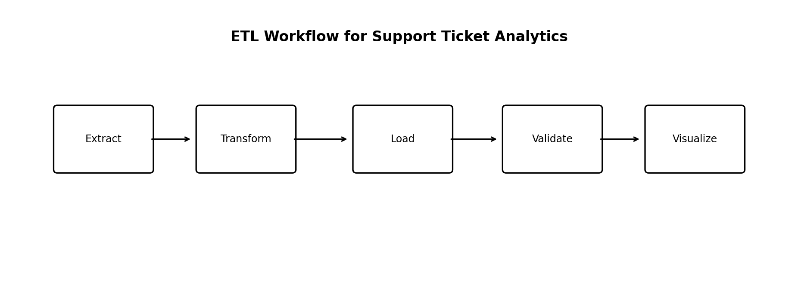
Figure 1: ETL workflow for the support ticket analytics project

2.1 Extract
Extract means collecting data from one or more sources. In this project, the source is the support ticket dataset, which can be imported from CSV, Excel, database, or web source. The extraction step is not only about loading the file; it also involves understanding the source structure, checking headers, identifying delimiters, and confirming whether the raw file contains clean tabular data.
- Possible source types: CSV, Excel, database, web, or folder
- Check if the first row contains headers
- Verify delimiter and encoding in CSV files
- Inspect if the source contains merged cells, extra blank rows, or metadata

2.2 Transform
Transform is the most important stage in Power BI ETL. In this stage, raw data is converted into clean, structured, and business-ready data. For the support ticket dataset, transformation includes changing data types, removing duplicates, handling null values, standardizing text, validating dates, replacing 'N/A' values, and ensuring consistency in status, priority, and SLA fields.
- Change data types correctly
- Remove duplicates using ticket_id
- Standardize text values such as priority, status, channel, and region
- Handle null values carefully based on business meaning
- Replace browser value 'N/A' with 'Unknown'
- Trim and clean text fields
- Validate date fields and duration metrics

2.3 Load
Load means sending the transformed dataset into the Power BI data model for reporting and visualization. At this stage, only clean and validated data should be loaded. The quality of the load stage directly affects the reliability of DAX measures, visuals, filters, and dashboard performance.
- Load only required columns to reduce model size
- Avoid unnecessary text-heavy columns if not needed in visuals
- Keep primary analysis columns ready for DAX and slicing
- Validate row count before and after load

2.4 Pro-Level ETL Practices
- Use meaningful applied steps in Power Query
- Remove unnecessary columns early for performance optimization
- Create a reusable and repeatable transformation pipeline
- Validate business rules such as Closed tickets should have resolved dates
- Separate raw data and processed data versions
- Document all major transformations for auditability

3. EDA (Exploratory Data Analysis) – Detailed Understanding
EDA is the process of exploring the dataset before final modeling or dashboard development. It helps in understanding the shape, structure, distributions, relationships, missing values, outliers, and possible business insights. EDA is one of the most important parts of an analytics project because it helps analysts ask the right questions before building visuals.
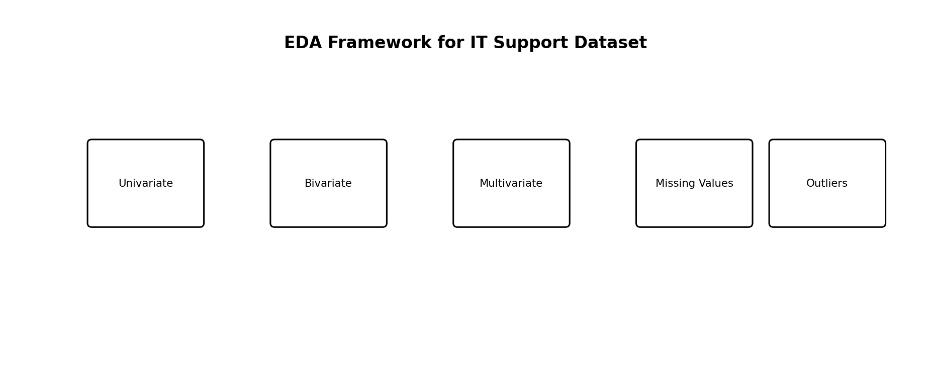
Figure 2: EDA framework applied to the support ticket dataset

3.1 Objectives of EDA in This Project
- Understand ticket volume and category distribution
- Identify which products and channels generate more tickets
- Study response and resolution time distributions
- Check missing values and data quality issues
- Detect outliers in numeric columns
- Understand how satisfaction is related to time metrics
- Identify business patterns by priority, region, and customer segment

4. Types of EDA and Their Use in This Dataset

4.1 Univariate Analysis
Univariate analysis means analyzing one variable at a time. It is the first stage of EDA and helps in understanding the distribution, frequency, central tendency, and spread of each column.
Column | Recommended EDA Method | Purpose
priority | Bar chart / frequency table | Find most common urgency levels
status | Bar chart / percentage distribution | Understand open vs closed workload
channel | Bar chart | Find preferred support channels
region | Bar chart | See regional ticket concentration
customer_satisfaction_score | Histogram / summary stats | Understand service rating distribution
first_response_time_hours | Histogram / box plot | Study response time spread and outliers
resolution_time_hours | Histogram / box plot | Study resolution performance

4.2 Bivariate Analysis
Bivariate analysis studies the relationship between two variables. This is highly useful in business analytics because it helps explain why one metric changes with another.
Analysis Pair | Business Question | Suggested Visual
priority vs resolution_time_hours | Do urgent tickets resolve faster? | Column chart / box plot
channel vs first_response_time_hours | Which channel responds fastest? | Bar chart
sla_breached vs customer_satisfaction_score | Does SLA breach reduce satisfaction? | Bar chart
issue_complexity_score vs resolution_time_hours | Does complexity increase resolution time? | Scatter plot
subscription_type vs resolution_time_hours | Do premium users get faster support? | Bar chart

4.3 Multivariate Analysis
Multivariate analysis studies more than two variables together. In Power BI, this is often achieved through matrices, scatter plots with legends, drill-down visuals, and filtered analysis.
- Priority + Channel + Resolution Time
- Region + Subscription Type + Satisfaction
- Category + Escalated + SLA Breached
- Customer Segment + Product + Ticket Count

5. Detailed EDA Functions and Their Use in This Dataset
The following EDA functions and checks are important for this project. Even though some are conceptually statistical, they can be performed through Power Query, Power BI visuals, summary tables, or DAX measures.
EDA Function / Check | Purpose | Use in This Dataset
Count | Count total records | Total support tickets
Distinct Count | Count unique values | Unique customers, unique products, unique categories
Min / Max | Find range | Min/Max response and resolution times
Mean (Average) | Central tendency | Average response time, resolution time, satisfaction
Median | Robust central tendency | Better for skewed resolution time
Mode | Most frequent category | Most common channel, status, or priority
Standard Deviation | Spread / variability | See consistency of response times
Frequency Distribution | Category concentration | Status, priority, region, product
Histogram | Distribution shape | Numeric columns like response and resolution time
Box Plot | Outlier detection and spread | Response and resolution time columns
Scatter Plot | Relationship between numeric variables | Resolution time vs satisfaction
Correlation (conceptual) | Measure relationship strength | Time metrics vs satisfaction

6. Missing Value Analysis (Empty vs Filled Values)
One of the important extra topics in Week 5 is analyzing missing values. Missing values can strongly affect KPIs, averages, filters, and charts. Therefore, before final dashboard creation, each column should be checked for empty (null / blank) and filled values.
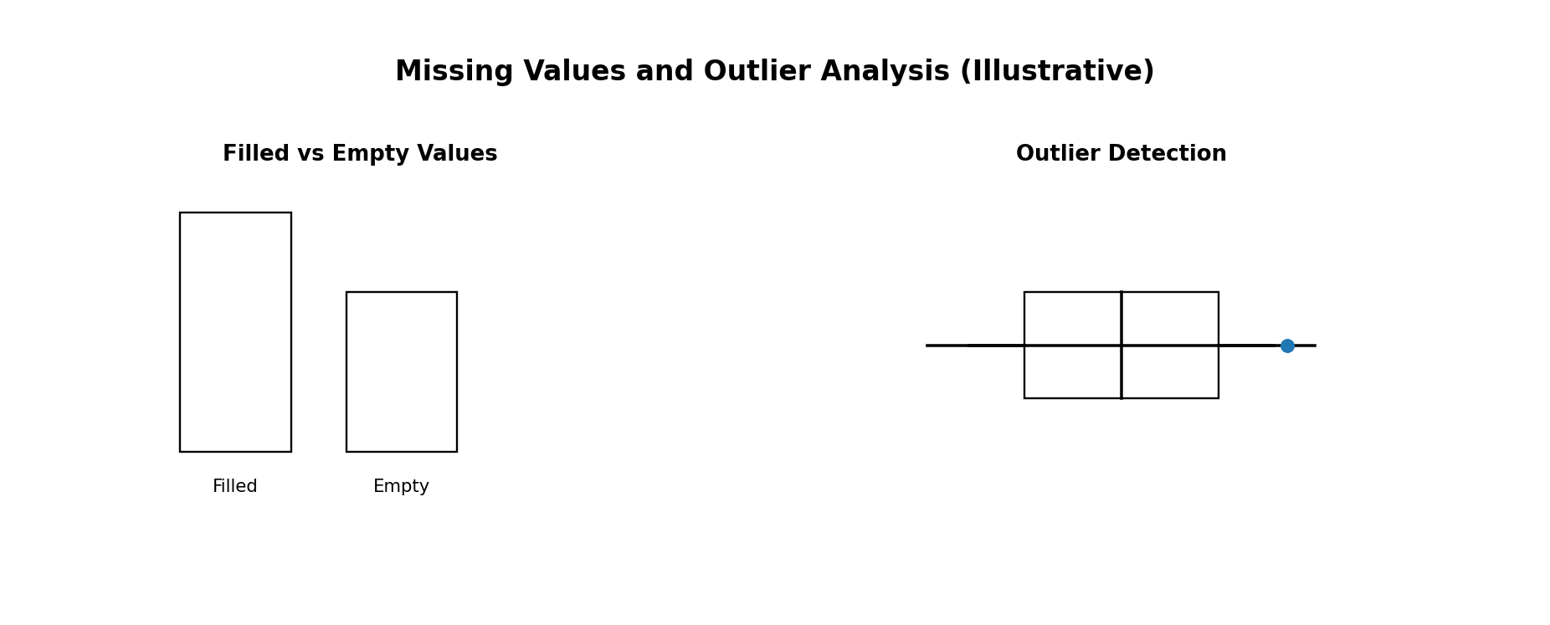
Figure 3: Illustrative representation of filled vs empty values and outlier analysis

6.1 Why Visualize Empty and Filled Values?
- To identify which columns are incomplete
- To measure data completeness before KPI creation
- To decide whether nulls should be removed, replaced, or retained
- To detect columns that may not be reliable for analysis

6.2 Best Columns to Check for Empty vs Filled Values
Column | Recommended Handling
resolution_notes | May be blank; replace with 'Not Provided' if needed
ticket_resolved_date | Can be blank for open tickets
resolution_time_hours | Can be blank for unresolved tickets
customer_satisfaction_score | May need mean or median if missing
browser | Replace N/A or blank with 'Unknown'
first_response_time_hours | Review before imputation

6.3 How to Visualize in Power BI
- Use Column Quality in Power Query (Valid / Error / Empty)
- Create a custom completeness table showing filled and blank counts
- Use stacked bar chart: Filled vs Empty by Column
- Use matrix table for missing percentage by important fields

7. Outlier Analysis
Outliers are unusually high or low values that differ significantly from the rest of the data. In this support ticket dataset, outliers are especially important in columns such as first_response_time_hours, resolution_time_hours, previous_tickets, customer_tenure_months, and issue_complexity_score.

7.1 Why Outliers Matter
- Can distort averages and KPI cards
- Can make normal performance look worse or better than reality
- Can indicate data entry errors
- Can also represent real but critical business cases

7.2 Important Columns for Outlier Detection
Column | Reason
first_response_time_hours | Extremely high values can distort average response KPI
resolution_time_hours | Very long tickets can skew resolution performance
customer_satisfaction_score | Check if values exceed expected rating range
previous_tickets | Very high counts may indicate repeated unresolved issues
customer_tenure_months | Unexpected values may indicate data issues
issue_complexity_score | Should remain within valid scale

7.3 Common Outlier Detection Methods
- Box plot method (IQR based)
- Z-score method (statistical)
- Min/Max business rule validation
- Visual inspection through sorted tables and histograms

7.4 Recommended Handling of Outliers
- Do not remove outliers blindly
- First validate whether the outlier is a data error or a real business case
- If it is a valid extreme ticket, keep it and analyze separately
- Use median-based KPIs when averages are heavily distorted
- Create a flag column for outlier cases if necessary

8. Applying EDA and ETL to the Support Ticket Dataset
For this specific dataset, the ETL and EDA workflow should be applied systematically. First, import the data, correct headers and data types, then clean and standardize important fields. After that, perform univariate analysis on key categorical and numeric columns, followed by bivariate and multivariate analysis to discover patterns.
- Import the raw support ticket dataset into Power BI / Power Query
- Check column headers and assign correct data types
- Standardize priority, status, channel, region, and gender values
- Handle missing values based on business logic
- Check duplicates using ticket_id
- Profile numeric columns using min, max, mean, median, and outlier checks
- Visualize empty vs filled values for important columns
- Perform EDA on priority, status, region, product, and timing metrics
- Identify relationships such as complexity vs resolution time and SLA vs satisfaction
- Load the cleaned and validated dataset for dashboard creation

9. Professional Best Practices for Week 5
- Always perform EDA before building final visuals
- Do not use only averages; compare with median when outliers exist
- Document all ETL steps clearly in Power Query
- Use column quality indicators to check empty and valid values
- Validate business logic, not just technical correctness
- Prefer business-driven cleaning over blind statistical replacement
- Keep a separate cleaned dataset version for reproducibility

10. Week 5 Learning Summary
Week 5 focused on ETL and EDA at a more professional level. The learning included understanding the complete ETL pipeline from extraction to transformation and loading, as well as studying exploratory data analysis in detail. This included univariate, bivariate, and multivariate analysis, missing value analysis, visualization of empty versus filled values, and outlier detection. These concepts are highly important because they ensure that the dashboard is built on reliable, well-understood, and analysis-ready data.
For the project 'Optimizing IT Support Team Performance Using Analytics,' Week 5 provides a strong analytical foundation. It helps ensure that future dashboards, KPIs, and business insights are based on trustworthy data and meaningful exploratory findings rather than only surface-level visualizations.

11. Conclusion
Week 5 was one of the most analytically important stages of the internship because it introduced professional-level EDA and ETL concepts. By understanding how to extract, transform, validate, and load data correctly, and by exploring the dataset deeply using univariate, bivariate, and multivariate analysis, the project becomes much stronger and more reliable. The additional focus on missing values, empty versus filled value visualization, and outlier detection makes the analysis more mature and industry-relevant. This week prepares the project for advanced dashboard development, DAX calculations, and final business insight generation.

